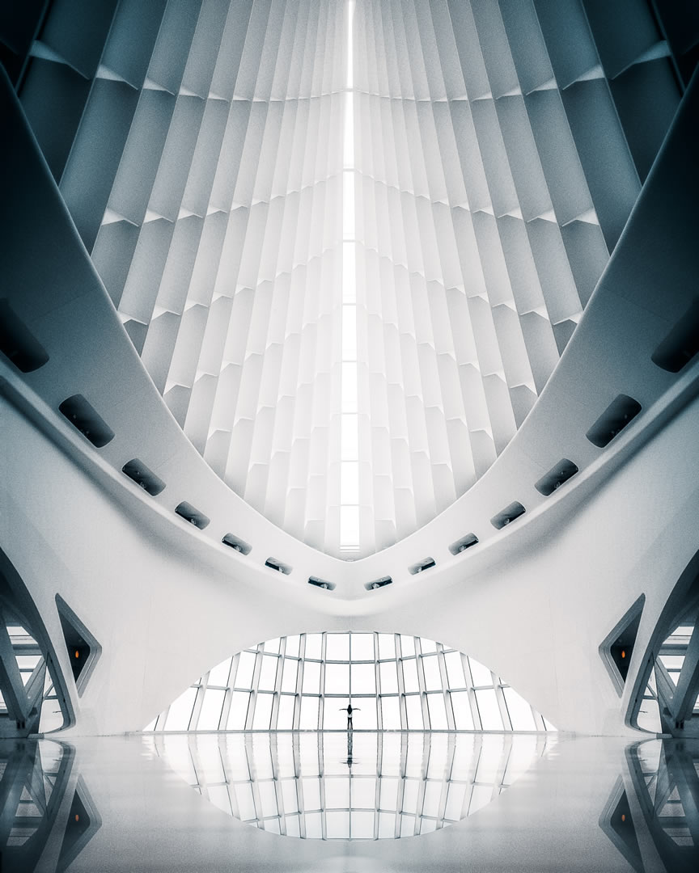



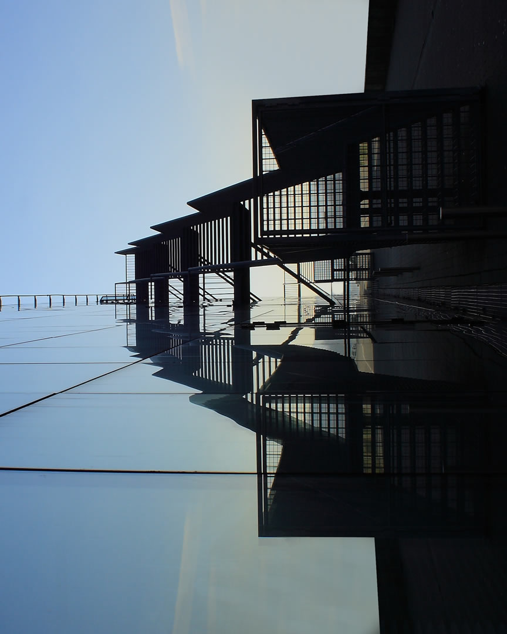

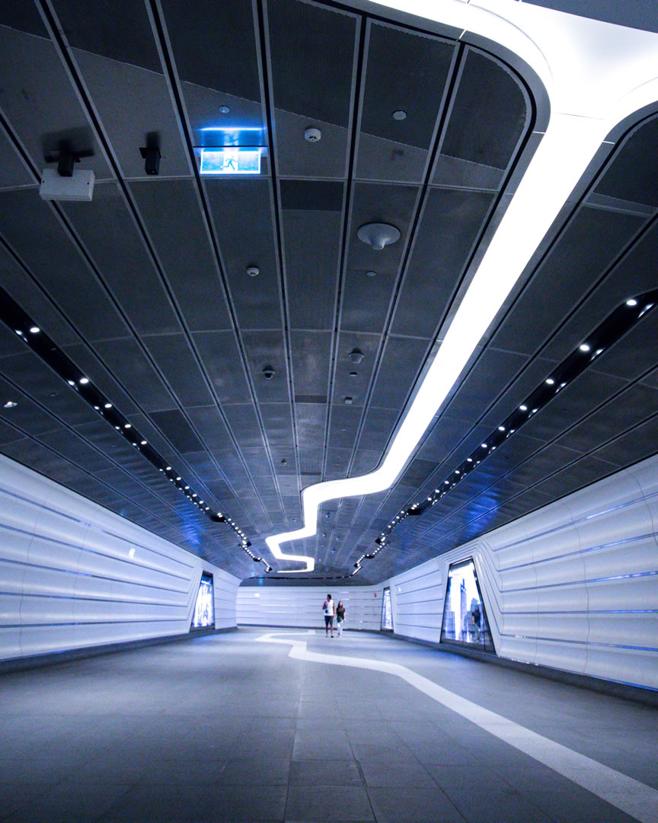

**Upright**

[Home](file:///C:\\Users\\Seyyed%20Javad%20Razavi\\Desktop\\web\\29\\templatemo_555_upright\\index.html" \l "home)

[Gallery](file:///C:\\Users\\Seyyed%20Javad%20Razavi\\Desktop\\web\\29\\templatemo_555_upright\\index.html" \l "gallery)

[About](file:///C:\\Users\\Seyyed%20Javad%20Razavi\\Desktop\\web\\29\\templatemo_555_upright\\index.html" \l "about)

[Contact](file:///C:\\Users\\Seyyed%20Javad%20Razavi\\Desktop\\web\\29\\templatemo_555_upright\\index.html" \l "contact)

[External](https://paypal.me/templatemo" \t "_parent)

Design: [TemplateMo](https://templatemo.com)

**Welcome to Upright**

Leftmost column is placed for logo and main menu. After that is an image column. Right side column is a 100% full-width content.

Right side can put many contents and it will scroll up / down. Left side is fixed. Parallax Image changes for different pages.

Quisque tincidunt, sem rutrum euismod ornare, tortor arcu tempus lorem, accumsan suscipit mauris lorem at lorem. Praesent feugiat mi at tortor tincidunt, ac consequat ante cursus.

[24 September 2020](file:///C:\Users\Seyyed%20Javad%20Razavi\Desktop\web\29\templatemo_555_upright\index.html)

Upright is free responsive HTML CSS template by [TemplateMo](https://templatemo.com/page/1). You can feel free to adapt and apply this layout for your commercial or non-commercial websites.

[22 September 2020](file:///C:\Users\Seyyed%20Javad%20Razavi\Desktop\web\29\templatemo_555_upright\index.html)

You are not allowed to re-distribute this template as a ZIP file on any template collection website for the template download purpose. Please contact us for more information.

[16 September 2020](file:///C:\Users\Seyyed%20Javad%20Razavi\Desktop\web\29\templatemo_555_upright\index.html)

You may want to support us by making [a small donation via PayPal](https://paypal.me/templatemo). That will be helpful. We hope you like this Upright Template for your work.

**Upright Gallery**

* [All](javascript:void(0);)
* [Portraits](javascript:void(0);)
* [Nature](javascript:void(0);)
* [Animals](javascript:void(0);)
* [Buildings](javascript:void(0);)



***Dreamy Honey***

[View more](file:///C:\Users\Seyyed%20Javad%20Razavi\Desktop\web\29\templatemo_555_upright\img\gallery\portrait-01.jpg) 

***Dreamy Honey***

[View more](file:///C:\Users\Seyyed%20Javad%20Razavi\Desktop\web\29\templatemo_555_upright\img\gallery\building-01.jpg) 

***Dreamy Honey***

[View more](file:///C:\Users\Seyyed%20Javad%20Razavi\Desktop\web\29\templatemo_555_upright\img\gallery\nature-01.jpg) 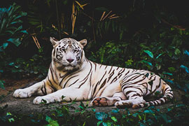

***Dreamy Honey***

[View more](file:///C:\Users\Seyyed%20Javad%20Razavi\Desktop\web\29\templatemo_555_upright\img\gallery\animal-01.jpg) 

***Dreamy Honey***

[View more](file:///C:\Users\Seyyed%20Javad%20Razavi\Desktop\web\29\templatemo_555_upright\img\gallery\building-02.jpg) 

***Dreamy Honey***

[View more](file:///C:\Users\Seyyed%20Javad%20Razavi\Desktop\web\29\templatemo_555_upright\img\gallery\nature-02.jpg) 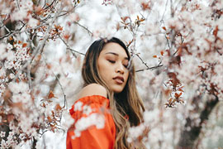

***Dreamy Honey***

[View more](file:///C:\Users\Seyyed%20Javad%20Razavi\Desktop\web\29\templatemo_555_upright\img\gallery\portrait-02.jpg) 

***Dreamy Honey***

[View more](file:///C:\Users\Seyyed%20Javad%20Razavi\Desktop\web\29\templatemo_555_upright\img\gallery\animal-02.jpg) 

***Dreamy Honey***

[View more](file:///C:\Users\Seyyed%20Javad%20Razavi\Desktop\web\29\templatemo_555_upright\img\gallery\building-03.jpg)

[1234](javascript:void(0);)

**About Upright CSS Template**

If you want to support TemplateMo, you can contribute [a small donation via **PayPal**](https://paypal.me/templatemo). This will be very helpful. Thank you.

Aliquam ornare varius erat vel aliquet. Proin ac neque a tortor tristique semper eget eget sapien. Morbi vitae diam a odio lobortis mattis sed nec justo.

Suspendisse sagittis tortor vel turpis aliquet, vitae molestie erat luctus.

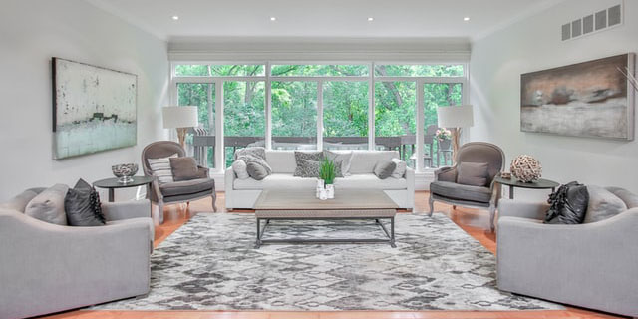

Duis fringilla eget purus luctus sodales. Sed auctor odio quis ligula dignissim efficitur vitae vitae quam.

**Contact Upright**

Top of Form



Bottom of Form



*120-240 eget purus luctus sodales. Sed  
auctor odio quis ligula dignissim efficitur  
vitae vitae quam 16502*

* [Tel: 010-020-0340](tel:0100200340)
* [Email: info@company.com](mailto:info@company.com)